**SQL Exercises**

**1. Create the tables described below:**

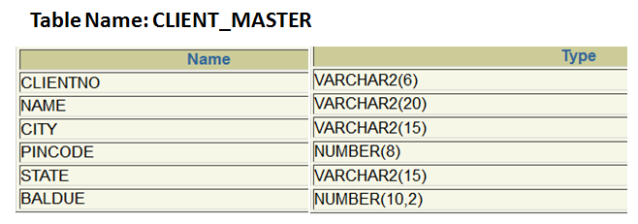

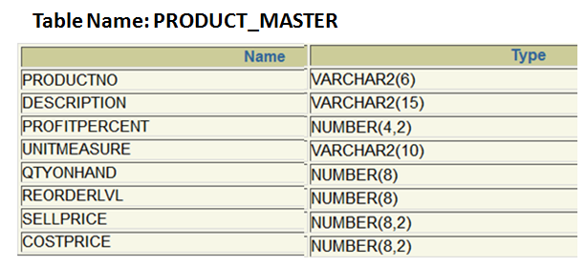

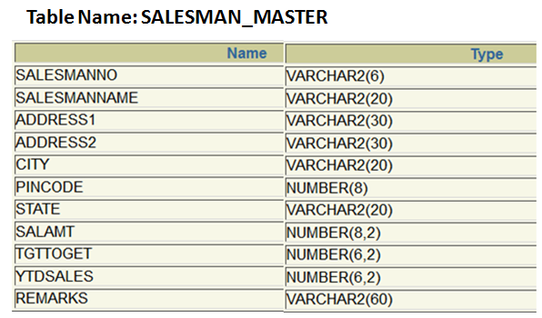

**Solution:**

**Table Name: CLIENT_MASTER**

**CREATE TABLE CLIENT_MASTER(**

**CLIENTNO varchar2(6), NAME varchar2(20),**

**ADDRESS1 varchar2(30), ADDRESS2 varchar2(30),**

**CITY varchar2(15), PINCODE number(8),**

**STATE varchar2(15), BALDUE number(10,2));**

**Table Name: PRODUCT_MASTER**

**CREATE TABLE PRODUCT_MASTER(**

**PRODUCTNO varchar2(6), DESCRIPTION varchar2(15),**

**PROFITPERCENT number(4,2), UNITMEASURE varchar2(10),**

**QTYONHAND number(8), REORDERLVL number(8),**

**SELLPRICE number(8,2), COSTPRICE number(8,2));**

**Table Name: SALESMAN_MASTER**

**CREATE TABLE SALESMAN_MASTER(**

**SALESMANNO varchar2(6), SALESMANNAME varchar2(20),**

**ADDRESS1 varchar2(30), ADDRESS2 varchar2(30),**

**CITY varchar2(20), PINCODE number(8),**

**STATE varchar2(20), SALAMT number(8,2),**

**TGTTOGET number(6,2), YTDSALES number(6,2),**

**REMARKS varchar2(60));**

**2. Insert the following data into their respective tables:**

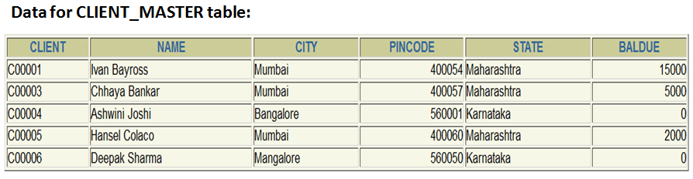

**INSERT INTO Client_Master (ClientNo, Name, City, PinCode, State, BalDue)**

**VALUES ('C00001', 'Ivan Bayross', 'Mumbai', 400054, 'Maharashtra', 15000);**

**INSERT INTO Client_Master (ClientNo, Name, City, Pincode, State, BalDue)**

**VALUES ('C00003', 'Chhaya Bankar', 'Mumbai', 400057, 'Maharashtra', 5000);**

**INSERT INTO Client_Master (ClientNo, Name, City, PinCode, State, BalDue)**

**VALUES ('C00004', 'Ashwini Joshi', 'Bangalore', 560001, 'Karnataka', 0);**

**INSERT INTO Client_Master (ClientNo, Name, City, PinCode, State, BalDue)**

**VALUES ('C00005', 'Hansel Colaco', 'Mumbai', 400060, 'Maharashtra', 2000);**

**INSERT INTO Client_Master (ClientNo, Name, City, PinCode, State, BalDue)**

**VALUES ('C00006', 'Deepak Sharma', 'Mangalore', 560050, 'Karnataka', 0);**

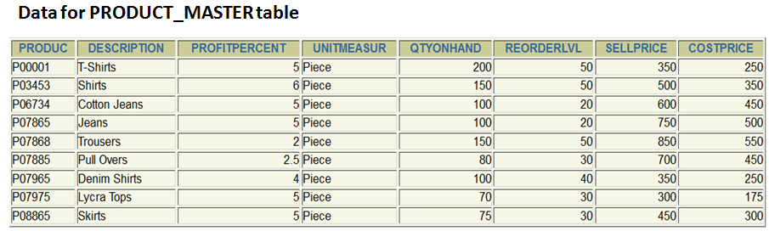

**INSERT INTO Product_Master**

**VALUES ('P00001', 'T-Shirts', 5, 'Piece', 200, 50, 350, 250);**

**INSERT INTO Product_Master**

**VALUES ('P03453', 'Shirts', 6, 'Piece', 150, 50, 500, 350);**

**INSERT INTO Product_Master**

**VALUES ('P06734', 'Cotton Jeans', 5, 'Piece', 100, 20, 600, 450);**

**INSERT INTO Product_Master**

**VALUES ('P07865', 'Jeans', 5, 'Piece', 100, 20, 750, 500);**

**INSERT INTO Product_Master**

**VALUES ('P07868', 'Trousers', 2, 'Piece', 150, 50, 850, 550);**

**INSERT INTO Product_Master**

**VALUES ('P07885', 'Pull Overs', 2.5, 'Piece', 80, 30, 700, 450);**

**INSERT INTO Product_Master**

**VALUES ('P07965', 'Denim Shirts', 4, 'Piece', 100, 40, 350, 250);**

**INSERT INTO Product_Master**

**VALUES ('P07975', 'Lycra Tops', 5, 'Piece', 70, 30, 300, 175);**

**INSERT INTO Product_Master**

**VALUES ('P08865', 'Skirts', 5, 'Piece', 75, 30, 450, 300);**

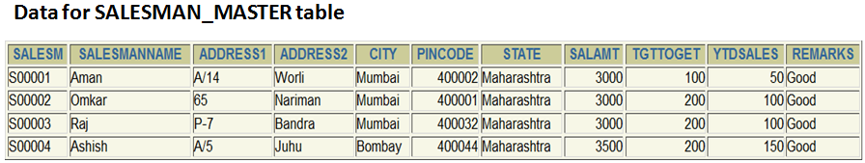

**INSERT INTO Salesman_Master**

**VALUES ('S00001', 'Aman', 'A/14', 'Worli', 'Mumbai', 400002, 'Maharashtra', 3000, 100, 50, 'Good');**

**INSERT INTO Salesman_Master**

**VALUES ('S00002', 'Omkar', '65', 'Nariman', 'Mumbai', 400001, 'Maharashtra', 3000, 200, 100, 'Good');**

**INSERT INTO Salesman_Master**

**VALUES ('S00003', 'Raj', 'P-7', 'Bandra', 'Mumbai', 400032, 'Maharashtra', 3000, 200, 100, 'Good');**

**INSERT INTO Salesman_Master**

**VALUES ('S00004', 'Ashish', 'A/5', 'Juhu', 'Bombay', 400044, 'Maharashtra', 3500, 200, 150, 'Good');**

**(SQL Select, Update, Delete, Alter, Rename & Drop commands)**

**Q3: Exercise on retrieving records from the table.**

1. Find out the names of all the clients.
2. Retrieve the entire contents of the Client_Master table.
3. Retrieve the list of names, city, and the state of all the clients.
4. List the various products available from the Product_Master table.
5. List all the clients who are located in Mumbai.
6. Find the names of salesmen who have a salary equal to Rs. 3000.

**Q4: Exercise on updating records in a table.**

1. Change the city of ClientNo. ‘C00005’ to ‘Bangalore’.
2. Change the BalDue of ClientNo ‘C00001’ to Rs. 1000.
3. Change the Cost Price of ‘Trousers’ to Rs. 950.00.
4. Change the city of the salesman to ‘Pune’.

**Q5: Exercise on deleting records in a table**

1. Delete all salesmen From the Salesman_Master whose salaries are equal to Rs. 3500.
2. Delete all products from Product_master table where the quantity on hand is equal to 100.
3. Delete from Client_Master Where the column state holds the value ‘Tamil Nadu’.

**Q6: Exercise on altering the table structure.**

1. Add a column called ‘Telephone’ of data type ‘number’ and size=’10’ to the Client_master table.
2. Change the size of SellPrice column in Product_Master to (10,2).

**Q7: Exercise on renaming the table.**

1. Change the name of the ‘Salesman_Master’ table to ‘Sman_Mast’.

**Q8: Exercise on deleting the table structure along with its data.**

1. Destroy the table ‘Client_Master’ along with its data.
2. Destroy the table ‘Product_Master’ along with its data.
3. Destroy the table ‘Sman_Mast’ along with its data.

**Q9: Create the following tables:**

**Table name: CLIENT_MASTER**

|  |  |  |  |
| --- | --- | --- | --- |
| **Column Name** | **Data Type** | **Size** | **Attributes** |
| CLIENTNO | Varchar | 6 | Primary Key / First letter must start with ‘C’ |
| NAME | Varchar | 20 | Not Null |
| CITY | Varchar | 15 |  |
| PINCODE | int | 8 |  |
| STATE | Varchar | 15 |  |
| BALDUE | int | 10,2 |  |

**CREATE TABLE CLIENT_MASTER(**

**CLIENTNO varchar2(6) PRIMARY KEY, NAME varchar2(20) NOT NULL,**

**ADDRESS1 varchar2(30), ADDRESS2 varchar2(30),**

**CITY varchar2(15), PINCODE number(8), STATE varchar2(15),**

**BALDUE number(10,2),**

**CONSTRAINT ck_client CHECK (CLIENTNO like 'C%'));**

**Insert the following data:**



INSERT INTO Client_Master (ClientNo, Name, City, PinCode, State, BalDue)

VALUES ('C00001', 'Ivan Bayross', 'Mumbai', 400054, 'Maharashtra', 15000); INSERT INTO Client_Master (ClientNo, Name, City, Pincode, State, BalDue)

VALUES ('C00003', 'Chhaya Bankar', 'Mumbai', 400057, 'Maharashtra', 5000);

INSERT INTO Client_Master (ClientNo, Name, City, PinCode, State, BalDue)

VALUES ('C00004', 'Ashwini Joshi', 'Bangalore', 560001, 'Karnataka', 0);

INSERT INTO Client_Master (ClientNo, Name, City, PinCode, State, BalDue)

VALUES ('C00005', 'Hansel Colaco', 'Mumbai', 400060, 'Maharashtra', 2000);

INSERT INTO Client_Master (ClientNo, Name, City, PinCode, State, BalDue)

VALUES ('C00006', 'Deepak Sharma', 'Mangalore', 560050, 'Karnataka', 0);

**Q10: Generate the SQL statements to perform the following computations on table data:**

a. List the names of all clients having ‘a’ as the second letter in their names.

b. List the clients who stay in a city whose first letter is ‘M’.

c. List all clients who stay in ‘Bangalore’ or ‘Mangalore’.